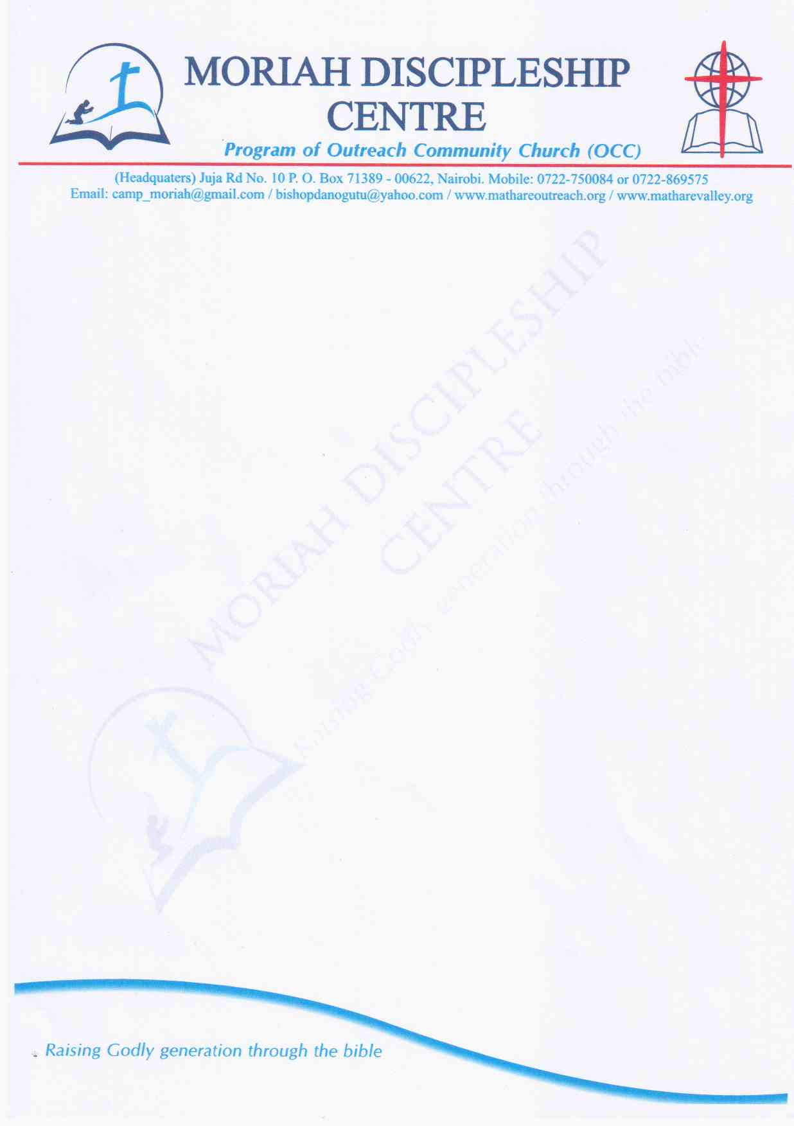

Moriah School of Discipleship was started by Mathare Community Outreach in the year 2013 as a discipleship center to cater for the growing need of disciplining students who graduate from high school. The school which is located in Maseno, Kisumu County, has been laboring to produce young Christian leaders through a seven month training program every year beginning the month of January to July.

* **The key focus areas include;**
* Discipleship & it’s dynamics
* Practical Life Skills – Creative arts
* Basic Bible/Theology courses
* Leadership Training
* World Missions & Field Exposure
* **The objectives are;**
* Understanding that Jesus gave the Church just one command; to make disciples who can make disciples.
* Make the definition of disciple clear and central.
* Follow the model Jesus used in disciple making
* **The expected outcome will be two fold, to the participants and the community.**

Participants:

* Deeper understanding of Christian living and a commitment to Biblical discipleship.
* Servant leadership based on character and integrity.
* Understanding of the contemporary issues of leadership.
* Clarity of vocation.
* Commitment to excellence and hard work.
* Youth with a capacity to create employment and engage in income generating projects.
  + Increased food production in Maseno as the farm will also serve as a model farm.
* Model responsible citizenship based on character, personal integrity and community service.

**WHAT CAMP MORIAH IS NOT**

1. A Bible School
2. A Rehabilitation centre
3. A Church
4. An alternative for short courses after Form 4

It is a Biblical Discipleship Program aimed at building a lifelong relationship journey with the Lord Jesus Christ based on Godly convictions........Ezra 7:10

**MSOD VISION**

To raise a generation of young people equipped holistically through the word of God.

**MSOD MISSION**

We exist to nature through teaching, correcting and training so that young followers of Christ may be thoroughly equipped for every good work as they advance in their areas of calling and career development.

**CORE VALUES**

Godliness, Commitment, Accountability, Integrity, Consistency

**MISSION VERSE**

All Scripture is God- breathed and is useful for Teaching, Rebuking, Correcting and Training in Righteousness:

**2 TIMOTHY 3:16-17:**

**Important Guidelines**

**Community**

This program offers you an opportunity to live and interact with other believers in a communal setting. You are all different and it is possible that you will not like somebody’s mannerism or his/her way of doing things. However, remember we are all here to allow God work within us and make us more like Christ. Let love for one another guide everything we do. In Philippians 2:1-11, we’re exhorted to be like Christ, esteeming others better than ourselves. Though somebody may say things or do things in a way you are not used, don’t be quick to judge unless it is out rightly against the scriptures; it may not necessarily be wrong but only different from the way you are used to.

**Your responsibility**

What you will obtain from this program could be summed up by the word; goal and attitude. You’ll reap the greatest benefit by setting goals of excellence with all you do with an attitude of whole hearted openness to all that God has for you.

* The program will be geared towards helping the students build a foundational relationship with Jesus Christ. The relationship will be grown and nurtured through:
* Knowing God as revealed fully in Jesus Christ, through the scripture, by the Holy Spirit and through fellow believers in the body of Christ.
* Seeing the world as Jesus sees it; the people around us, those who are least evangelized, and our own situations.
* Doing the will of God, as confirmed by the scripture, the spirit and the counsel of fellow believers.
* Being in Christ daily, learning to rest and remain in Him, and to draw Life from Him.

These are the four pillars upon which our curriculum and mantra is built.

***In Moriah; we exist to know God and make Him known, see the world as Christ sees it, to do God’s will and to have a consistent walk with Christ.***

**Successes**

**Transformation:** a number of Students have given their lives to Jesus Christ and now serves in different ministries in their churches e.g. Praise & Worship, Ushering and leadership roles. Some of these students used to engage in bad vices like drug abuse etc

The students have successfully learnt various farming skills and can readily carry dairy, poultry farming and horticulture.